# Project 1

In the below figure is the user use case where the admin can check plagiarism and his includes uploading the file to be checked across the database for plagiarism and this also includes counting the similar words in the documents and counting the populate words too and calculating the percentage of similarity between document and the documents in the database.

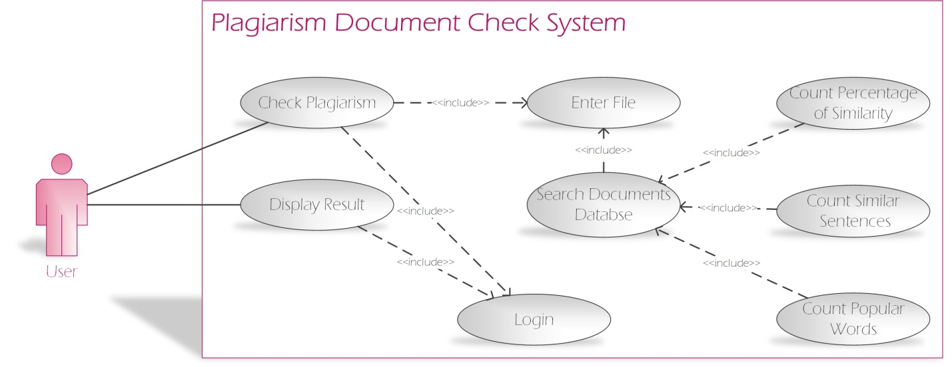

Figure ‎3‑2 User Use Case

The admin can modify user data or add a user to the system, also the admin is responsible for accepting or rejecting a project and then sending a message to the user informing him weather the project is accepted or not as shown in figure 3-2 below

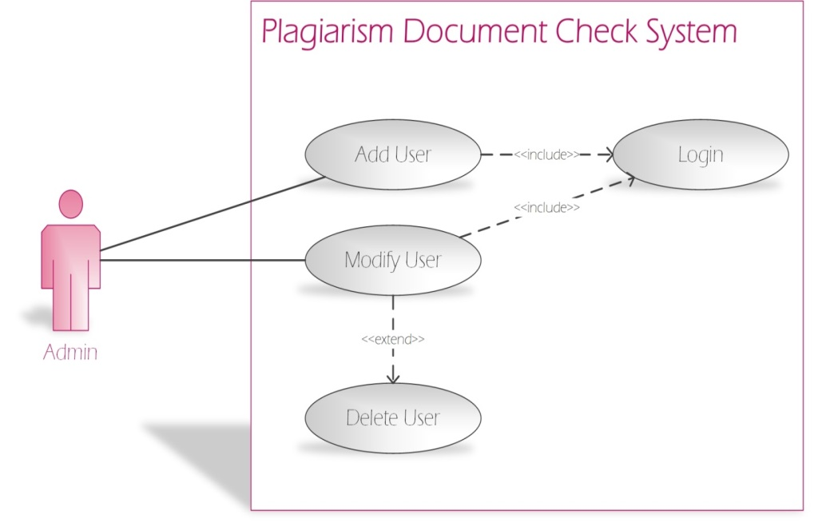

Figure ‎3‑3 Admin Use case

# Project 2

The user can send the command to for the login. Then he can upload the file which will result in generating the password. Then he can send and log out of system. The receiver at his end also can log in and can download the data which can be printed out easily, after printing exam the system will be send message to Exam controller.



Figure ‎0.2 usecase